American Public Turns Anti-War … Warmongers Desperately Reply, “But War Is GOOD for Us!”
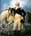
Submitted by George Washington on 04/29/2014 10:41 -0400
- Afghanistan
- Iran
- Iraq
- Middle East
- national security
- Reality
- Ukraine

The American people are now overwhelmingly opposed to more war in Ukraine, Syria, Iran and elsewhere.
Those who get rich from war (the military-industrial complexers and big banks) and their lackeys are desperate to reverse this trend.
As such, they are resorting to more and more outlandish justifications for war.
For example, Ian Morris has written an entire book arguing that war is the best thing ever, the only thing which has lifted us out of poverty and barbarianism. And – yes – he even says that war brings peace.
David Swanson provides a must-read dismantling of Morris’ book.
Morris writes this week in the Washington Post:
War has not only made us safer, but richer, too.
In reality, security experts – conservative hawks and liberal doves alike – agree that waging war in the Middle East weakens national security and increases terrorism. See this, this, this, this, this, this and this. So it doesn’t make us safer.
And there is now overwhelming evidence that war is horrible for the economy, and makes us poorer.
Morris continues:
Thinkers have long grappled with the relationships among peace, war and strength. Thomas Hobbes wrote his case for strong government, “Leviathan,” as the English Civil War raged around him in the 1640s.
In reality, Hobbes was an authoritarian who argued – just like (1) the leading Nazi legal scholar and philosopher who created the justification for “total war” to destroy those labeled an “enemy” of the Nazi state (Carl Schmitt), (2) Machiavelli, and (3) the father of the Neoconservatives (Leo Strauss) – that the public should be intentionally whipped into a frenzy of fear so that they would be willing to give up their rights and cede their freedoms to the sovereign.
Indeed, Morris accidentally reveals that he is cut from the exact same cloth when he states:
People almost never give up their freedoms — including, at times, the right to kill and impoverish one another — unless forced to do so.
In other words, freedom bad … authoritarian leader good.
Morris writes:
Since 1914, we have endured world wars, genocides and government-sponsored famines, not to mention civil strife, riots and murders. Altogether, we have killed a staggering 100 million to 200 million of our own kind. But over the century, about 10 billion lives were lived — which means that just 1 to 2 percent of the world’s population died violently. Those lucky enough to be born in the 20th century were on average 10 times less likely to come to a grisly end than those born in the Stone Age.
In other words, War Is Peace, Freedom Is Slavery, and Ignorance Is Strength. I’ve seen this movie before.
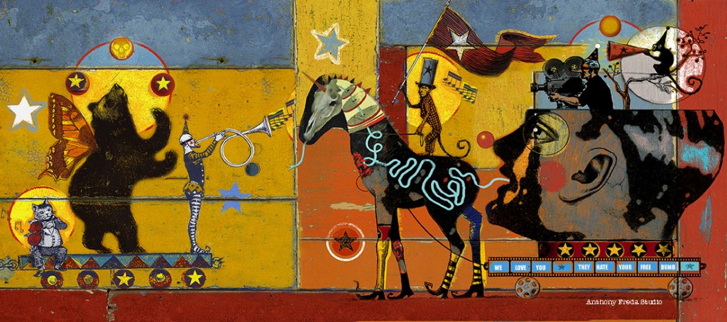Artwork by Anthony Freda
Morris cheerfully notes:
And since 2000, the United Nations tells us, the risk of violent death has fallen even further, to 0.7 percent.
Unless, of course, you live in Iraq, Afghanistan, Libya, Syria or one of the other countries targeted for regime change … in which case your risk of violent death is very high.
Morris argues:
Washington [must] embrace [] its role as the only possible globocop in an increasingly unstable world — a world with far deadlier weapons than Britain could have imagined a century ago.
In other words, Morris is an unrepentant apologist for American empire.
Amusingly, the vast majority of comments to Morris’ Washington post essay attack him for being a desperate shill and a fool.
But endless war is a feature – not a bug – of U.S. policy, and the American media (including the big “alternative” sites) are always pro-war.
So expect to hear crazier and crazier “justifications” for war.


